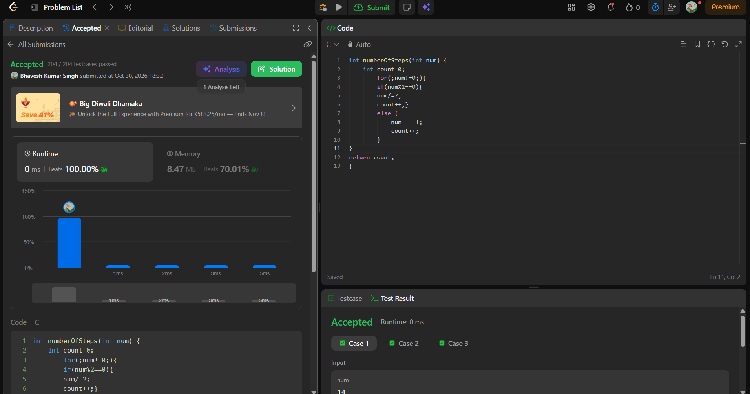
int numberOfSteps(int num) {
int count=0;
for(;num!=0;){
if(num%2==0){
num/=2;
count++;}
else {
num -= 1;
count++;
}
}
return count;
}

